Task 2:

ADDITION :

.data

a: .word 5

b: .word 10

.text

lw $t0 a($zero)

lw $t1 b($zero)

add $t2,$t0,$t1

li $v0 ,1

add $a0,$zero,$t2

syscall

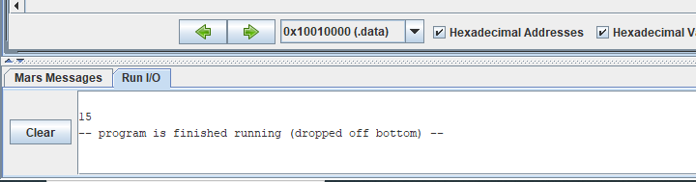

SUBTRACTION :

.data

a: .word 5

b: .word 10

.text

lw $t0 a($zero)

lw $t1 b($zero)

sub $t2,$t0,$t1

li $v0 ,1

sub $a0,$zero,$t2

syscall

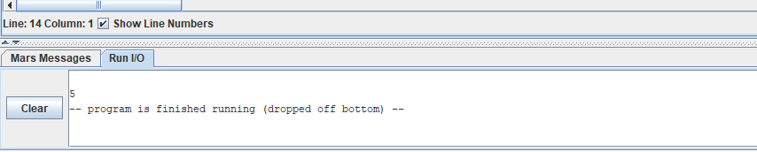

MULTIPLICATION:

.data

a: .word 5

b: .word 10

.text

lw $t0 a($zero)

lw $t1 b($zero)

mult $t0,$t1

mflo $s0

li $v0 ,1

add $a0,$zero,$s0

syscall

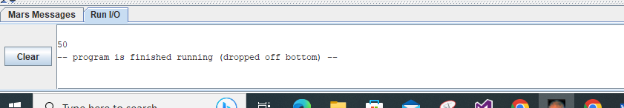

Lab task 1 :

.data

age: .asciiz "Enter your age :"

mes: .asciiz "\n your age is :"

.text

li $v0, 4

la $a0,age

syscall

li $v0, 5

syscall

move $t0, $v0

li $v0, 4

la $a0,mes

syscall

li $v0,1

move $a0 ,$t0

syscall

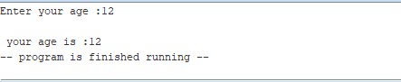

Task 3

Without user:

.data

a: .word 5

b: .word 10

c: .word 15

d: .word 10

.text

lw $t0 a($zero)

lw $t1 b($zero)

add $t2,$t0,$t1

li $v0 ,1

add $a0,$zero,$t2

lw $t4 c($zero)

add $t5, $t2,$t4,

li $v0 ,1

add $a0,$zero,$t5

lw $t3 d($zero)

sub $t6,$t3,$t5

li $v0 ,1

sub $a0,$zero,$t6

syscall

li $v0,10

syscall

TASK 4 :

USER ADDITION:

.data

a: .asciiz "Enter the first number :"

b: .asciiz "\nEnter the second number :"

.text

la $a0,a

li $v0,4

syscall

li $v0,5

syscall

move $t0,$v0

la $a0,b

li $v0,4

syscall

li $v0,5

syscall

move $t1 ,$v0

add $t2,$t0,$t1

li $v0 ,1

add $a0,$zero,$t2

syscall

li $v0,10

syscall

